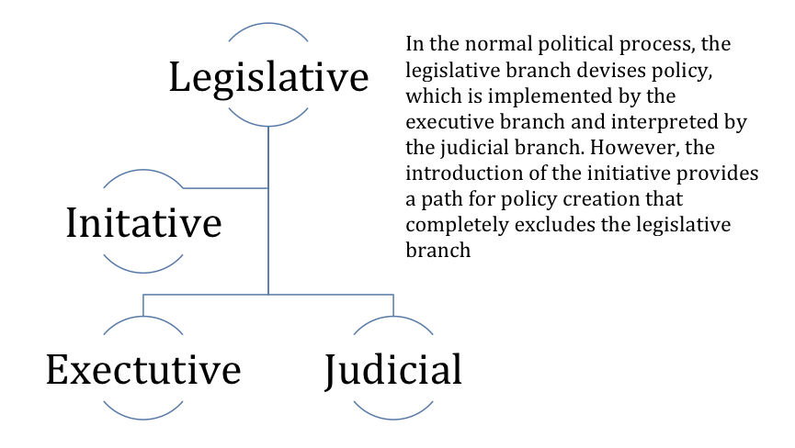

Executive

Legislative

Judicial

Initiative

In the normal political process, the legislative branch devises policy, which is implemented by the executive branch and interpreted by the judicial branch. However, the introduction of the initiative provides a path for policy creation that completely excludes the legislative branch.